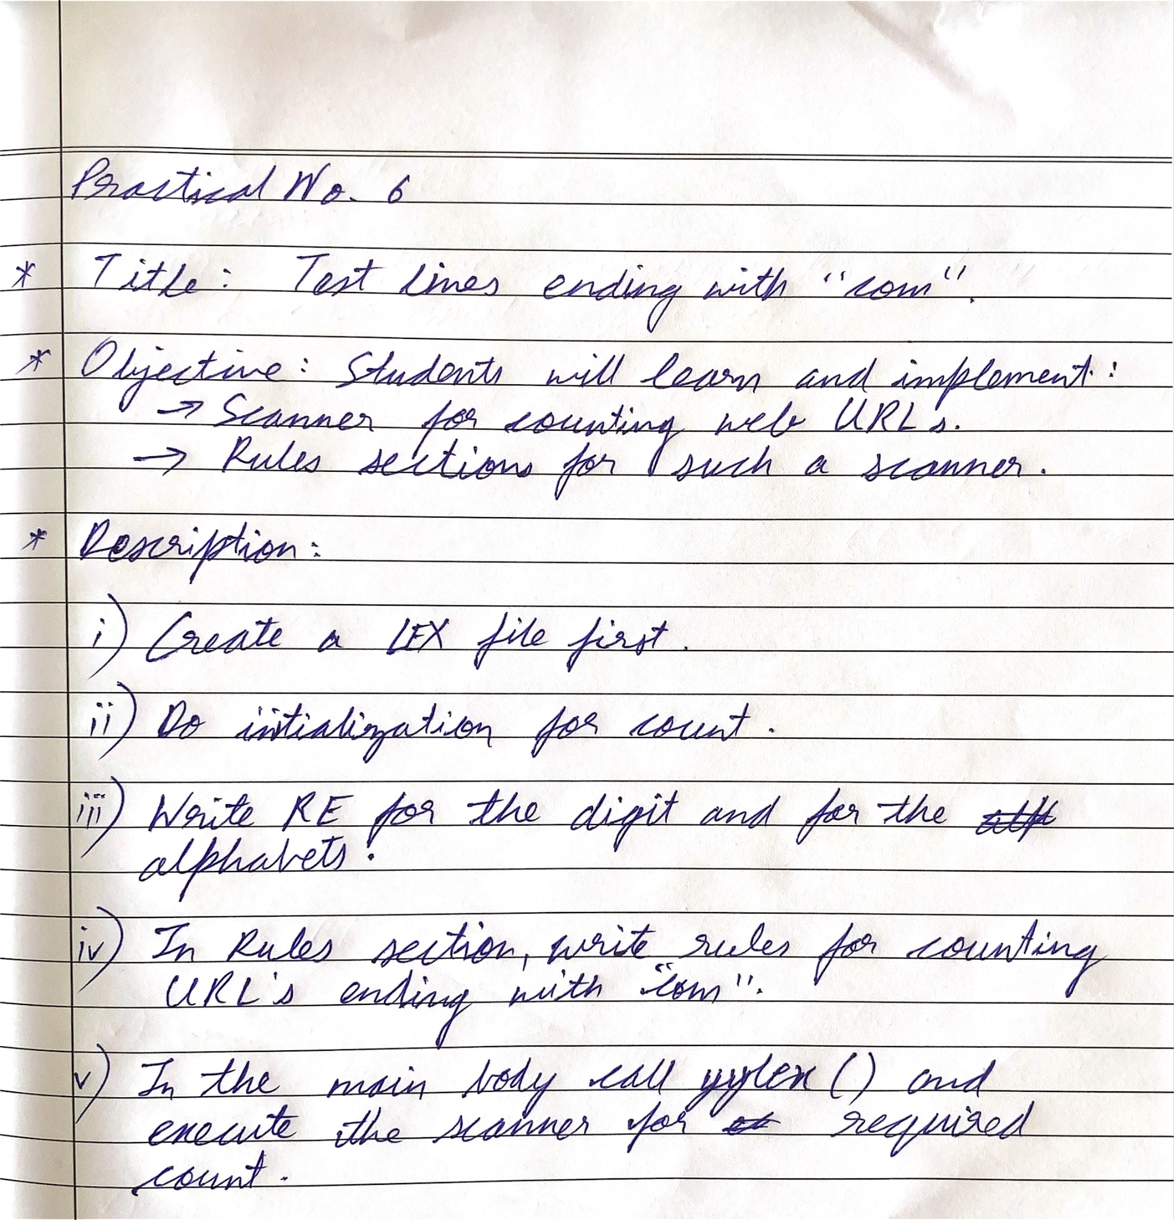

Code:

| %{ #include <stdio.h> #include <string.h>  int count = 0; %}  DIGIT [0-9] ALPHA [a-zA-Z] DOMAIN [a-zA-Z0-9.-]+ TLD \.com  %% {DOMAIN}{TLD}  {  printf("%s\n", yytext); // Print the matched .com website  count++; // Increment the count for .com websites } %%   int main()  {  yylex();  printf("Total .com websites: %d\n", count);  return 0; }  int yywrap(void)  {  return 1; // Return non-zero to indicate no more input files } |
| --- |

Output:

